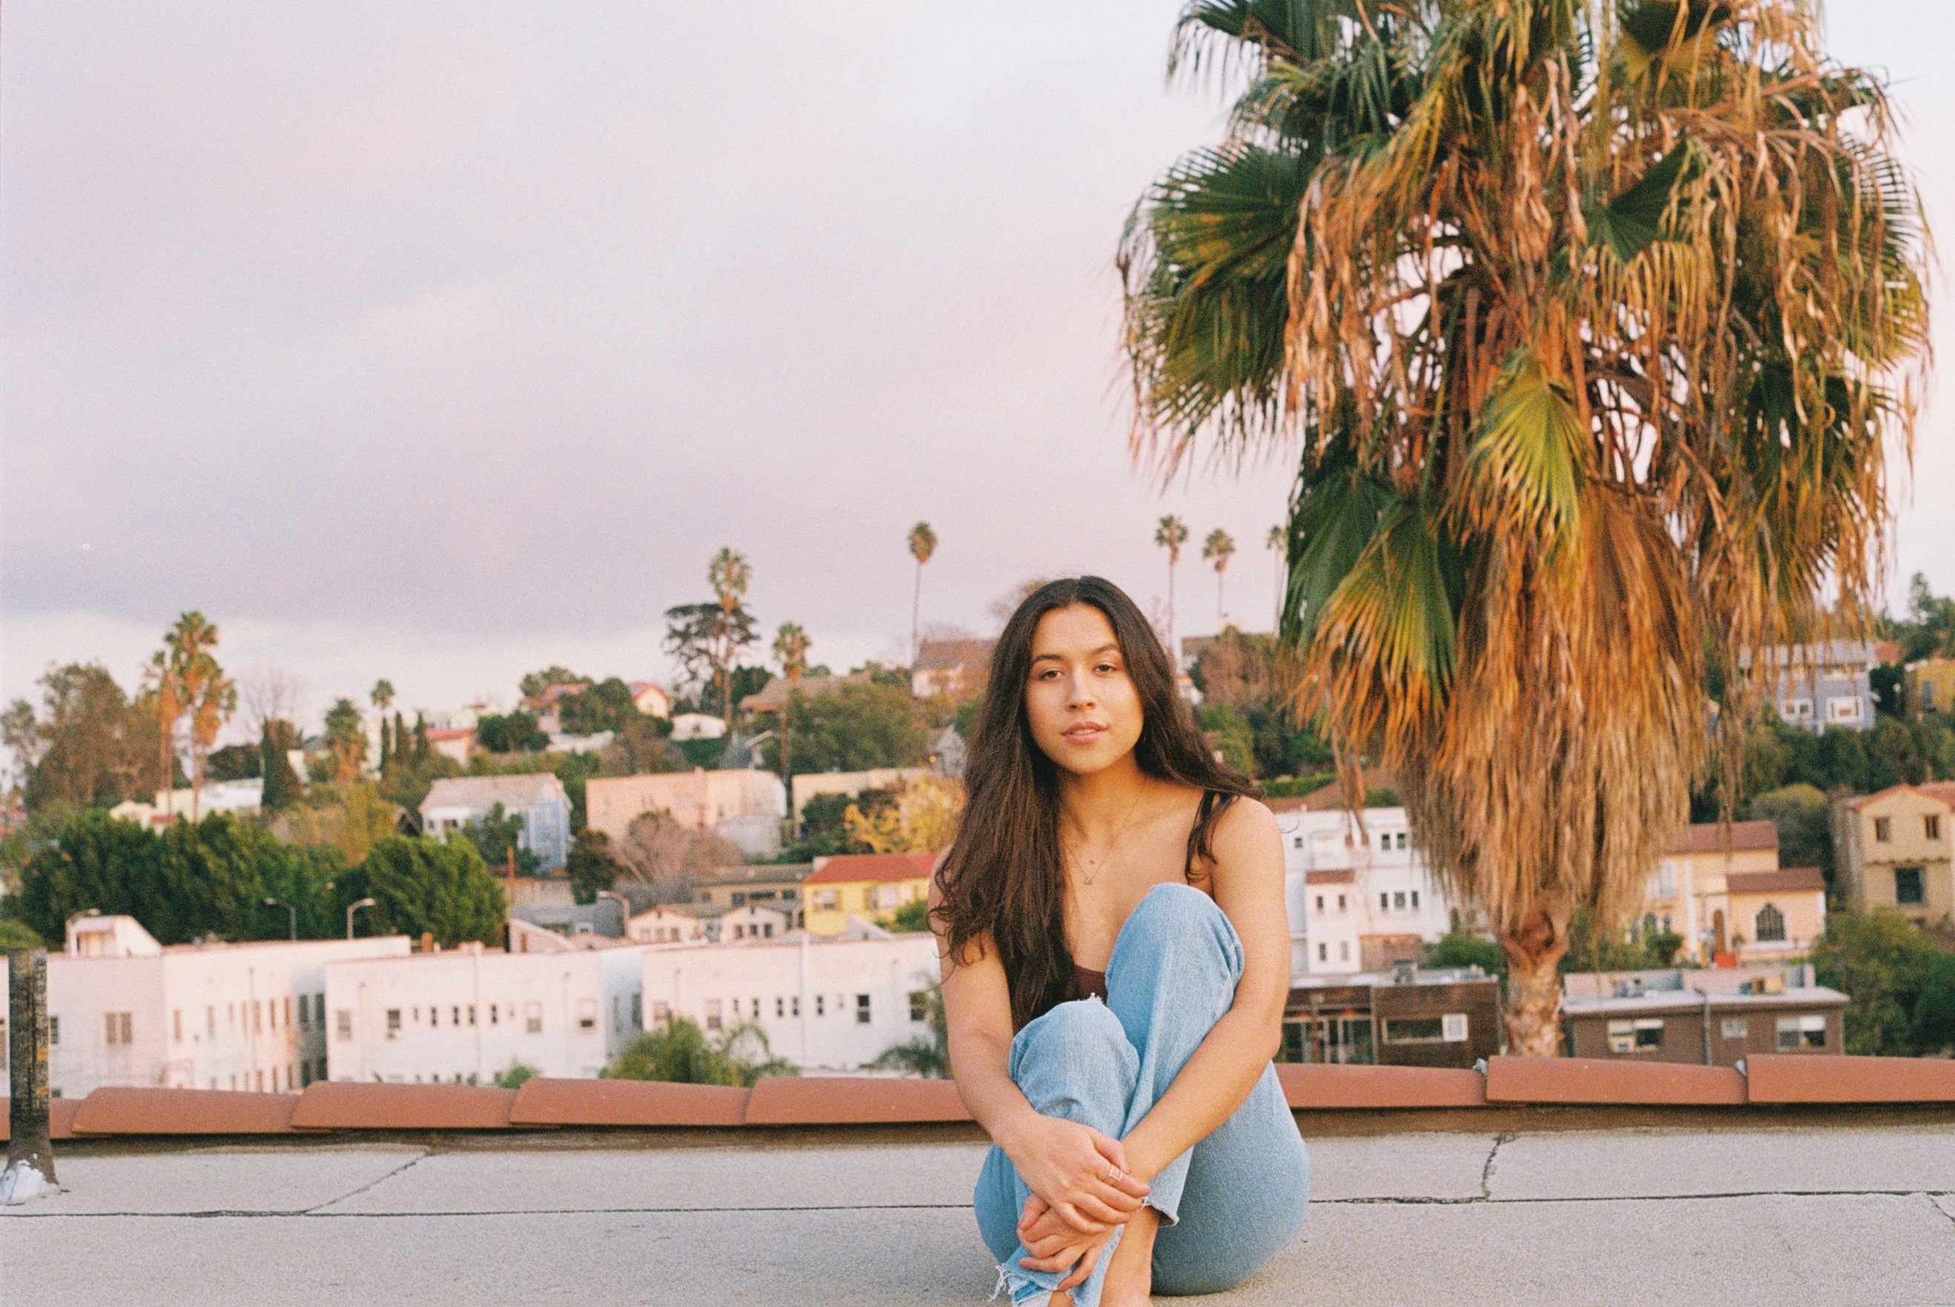
LOS ANGELES, CA (FEB 19th, 2020) – Singer/Songwriter Bryce Drew releases her first single ‘Lucky Number’, a strong introduction to her authentic, timeless, and soulful sound. The song’s intuitive melody follows the narrative of Bryce noticing her Lucky Number around and it being her surefire reminder to trust that she is in the right place.
It was two years ago on a writing trip to LA when Bryce began documenting every time she saw the number “19” on her Instagram highlights. After a month of her number appearing more frequently than ever, Bryce spontaneously decided to extend her stay in LA. During that time (when she was originally supposed to be back in Nashville) she found herself sitting in the studio of powerhouse producer, songwriter, and multi-instrumentalist Greg Wells (Dua Lipa/Adele/Katy Perry). Bryce played a song for Wells live on her guitar that day, which led to two, which led to three, which led to him saying “I want to make your record.” Within a few months, Bryce was moving to LA to begin recording with her dream producer.
Co-written and produced by Wells, Lucky Number’s entire creation process from songwriting all the way to mastering was filmed by pureMix.net and released throughout their 11 - episode video series, Start to Finish, where members have had the rare opportunity to be a fly-on-the-wall in the studio. Delivered with powerful vocal conviction, both those who have been watching and those who are only first listening can tell that the lyric of Lucky Number is undeniably honest to Bryce’s life. “This is far more than a song about a number for me,” says Bryce. “My entire life, the number 19 has been a constant reminder of belonging, identity, and hope-- and I hope that that’s just the feeling ‘Lucky Number’ gives my audience. I hope that when they listen, they hear a voice of a friend telling them that they are right where they are supposed to be.” This is a warm welcome from a promising new artist.

Boilerplate: Originally from the cultural melting pot of Miami, Florida, 24-year-old Bryce Drew’s music can be similarly described as a melting pot of genre. Influenced by artists such as India.Arie, Joni Mitchell, Adele, and Tracy Chapman, Bryce uses her identifiable vocal phrasing and picturesque storytelling to blend pop, folk, and soul. After spending four years in Nashville studying Songwriting & Music Business at Belmont University, Bryce relocated to Los Angeles, where she is currently recording with Grammy-winning producer Greg Wells (One Republic/Celine Dion/Grace Vanderwaal) for her debut project. The two are currently featured in an 11-episode series on pureMix.net called "Start to Finish", documenting the creation of Bryce's song "Lucky Number" from the very beginning of the songwriting process all the way to mastering. “Lucky Number" is set to release February 19th 2020, followed by another single in March, all leading to a four song EP later in the spring. In the meantime, Bryce can be found around LA performing at iconic singer/songwriter venues such as the Hotel Café and has recently toured as the support act for Nina Nesbitt.

